### (Admin Side) User Story for Admin/Doctor Dashboard

|  |  |
| --- | --- |
| **As a** | Logged in admin of my application |
| **I want** | to view the admin dashboard of patient details |
| **So that** | I can view all the patient details, issues, payment mode, etc and can also store the data and search patient information whenever required |
| **Acceptance Criteria** | 1. Registered Admin can log In to the App 2. System navigates the admin to the home page 3. On the home page Admin can clearly view the dashboard that contains:  * Patient personal information * Patient Issue * Patient mode of payment, etc   (Refer: Appendix 2, Wireframe 1 & Appendix 3 – Data Table)   1. System stores the patient information in tables so that admin can view and search for the patient whenever required and the system displays it |

**Appendix 1:** ‘Admin Dashboard’ Process Flow

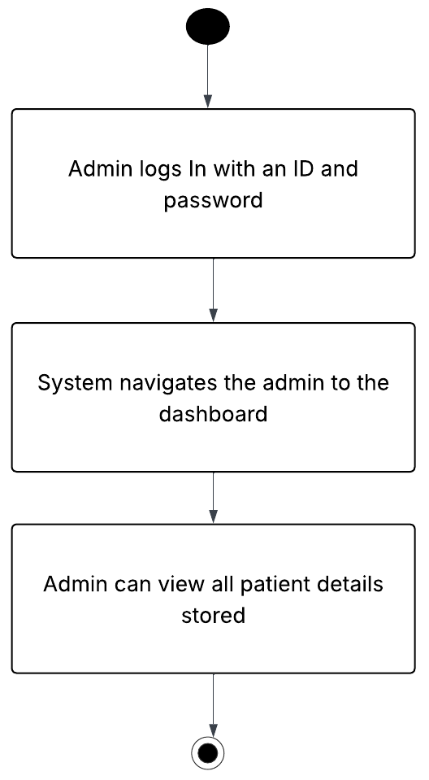

**Appendix 2:** Display ‘Admin Dashboard’ Page, Wireframe 1



**Appendix 3:** Data Table for ‘Admin Dashboard’ page

|  |  |  |  |  |  |  |  |
| --- | --- | --- | --- | --- | --- | --- | --- |
| **Sr. No.** | **Field Name** | **Field Type** | **Content** | **Required Field?** | **Min. Char.** | **Max Char.** | **Notes** |
| 1 | Patient Name | Text | Gaurangi Jamdar | Yes | 1 | 100 | Fetched from patient database |
| 2 | Age | Numeric | 22 | Yes | 1 | 3 | Numeric age of the patient |
| 3 | Gender | Text | Male / Female | Yes | N/A | N/A | Stored as selected value |
| 4 | Address | Text | Andheri East | Yes | 5 | 100 | Patient's entered address |
| 5 | Issue | Text | Stomach Pain | Yes | 3 | 100 | Medical issue selected during booking |
| 6 | Appointment Date & Time | Date & Time | 30/07/2025- 7:30pm | Yes | N/A | N/A | Format: DD/MM/YYYY &HH:MM AM/PM |
| 7 | Payment Status | Label | Done Online / Cash | Yes | N/A | N/A | Indicates payment method also if its paid or not |
| 8 | Payment Icon | Icon Indicator | ✅ / ❗ | Yes | N/A | N/A | Visual representation of status |
| 9 | Search Box | Input Field | Saniya | Optional | N/A | N/A | For filtering/searching patient records by name |